**UNIVERSE OF ORIGIN:** Valoran (League of Legends)  
**LORE-ACCURATE ALIGNMENT:** chaotic evil (evil demon)  
**ORIGINAL CHARACTER LORE:**

Long, long ago, in a tower by the edge of the sea, a foolish young mage summoned something into the world that he was not prepared to control. What stepped before the boy was something older than recorded history. Something darker than a yawning, starless night. Something the world had desperately tried to forget—and in an instant, the mage, the creature, and the tower itself were lost to all of time.

At least, that's what the stories say.

In the [Freljord](https://leagueoflegends.fandom.com/wiki/Freljord" \o "Freljord), children frighten each other around the fire with tales of a monster that raises itself from untended graves in the ice, its body a shambling mass of helmets, bucklers, furs, and wood. In [Bilgewater](https://leagueoflegends.fandom.com/wiki/Bilgewater" \o "Bilgewater), drunken sailors trade accounts of something standing alone on a tiny, distant atoll from which no one has ever returned. An old [Targonian](https://leagueoflegends.fandom.com/wiki/Targon" \o "Targon) legend speaks of how a [child of twilight](https://leagueoflegends.fandom.com/wiki/Zoe" \o "Zoe) stole the only joy from a ragged, whispering horror, while veteran [Noxian](https://leagueoflegends.fandom.com/wiki/Noxian" \o "Noxian) soldiers prefer the fable of a lonely farmhand who was blamed for a poor harvest and fed to the crows, later returning to the world as a demon.

[Demacia](https://leagueoflegends.fandom.com/wiki/Demacia). [Ixtal](https://leagueoflegends.fandom.com/wiki/Ixtal" \o "Ixtal). [Piltover](https://leagueoflegends.fandom.com/wiki/Piltover" \o "Piltover). [Ionia](https://leagueoflegends.fandom.com/wiki/Ionia" \o "Ionia). [Shurima](https://leagueoflegends.fandom.com/wiki/Shurima" \o "Shurima). In every corner of [Runeterra](https://leagueoflegends.fandom.com/wiki/Runeterra" \o "Runeterra), these myths persist—reshaped, respun, and passed down by countless generations of storytellers. Stories of a thing that looks almost human and stalks places thick with fear.

But these are simply fables to frighten young children. No one would ever be afraid of a silly old monster called [Fiddlesticks](https://leagueoflegends.fandom.com/wiki/Fiddlesticks" \o "Fiddlesticks)...

Until now.

Something has awoken in the [Demacian hinterlands](https://leagueoflegends.fandom.com/wiki/Rocky_Highlands" \o "Rocky Highlands), drawn by the climate of rising fear and paranoia. Rural protectorates, separated from the capital by hundreds of miles of farmland, are emptying in mere days. Travelers vanish from the old footpaths. Guard patrols fail to report back from the edges of the kingdom. And wild-eyed survivors claw at their faces from the safety of roadside taverns, wailing of crows that aren't crows, sounds that aren't sounds, and a lopsided horror in the shape of a scarecrow that croaks in the stolen voices of the dead.

Most blame rogue mages. Such accusations are common in these days of rebellion.

Yet the truth is far worse. Something has returned, just as it had in the fictitious tale of the young mage in his seaside tower. An evil gone from the world for numberless centuries—long enough that the warnings of a nascent humanity passed into rumor, then myth, then legend... until all that remained were simple fables. An entity so utterly alien that it defies almost all contemporary knowledge of magic. So impossibly ancient that it has always been. So universally feared that even animals grow nervous when someone speaks its name.

In the wake of this revival, another tale, nearly lost to memory, has seen a resurgence throughout the hinterlands. A legend of a great evil that has no form, no thoughts, and no understanding of the world it inhabits, instead building itself into the crude shape of those that fear it. The terror of all living things, given life in that first terrible scream of creation. A demon before demons were known.

At least, that's what the stories say.

But Fiddlesticks is real.

**TL;DR LORE: (a story that can be filled out/tweaked)**  
An old demon. From the beginning of creation. Millenia ago he was summoned to this world by a young mage. The mage was not able to control it and it swallowed the mage and his tower out of existence. It feeds on fear itself and populates outskirts of towns/cities/villages. Even though it lives in this world for millenia, it is still young and inexperienced in taking shape and communing with this worlds inhabitants. Thus it takes form of a relatively poorly made scarecrow. With his magic he can command crows and peer into the minds of his pray looking for the most oppressed memories filled with fear, dread and remorse.

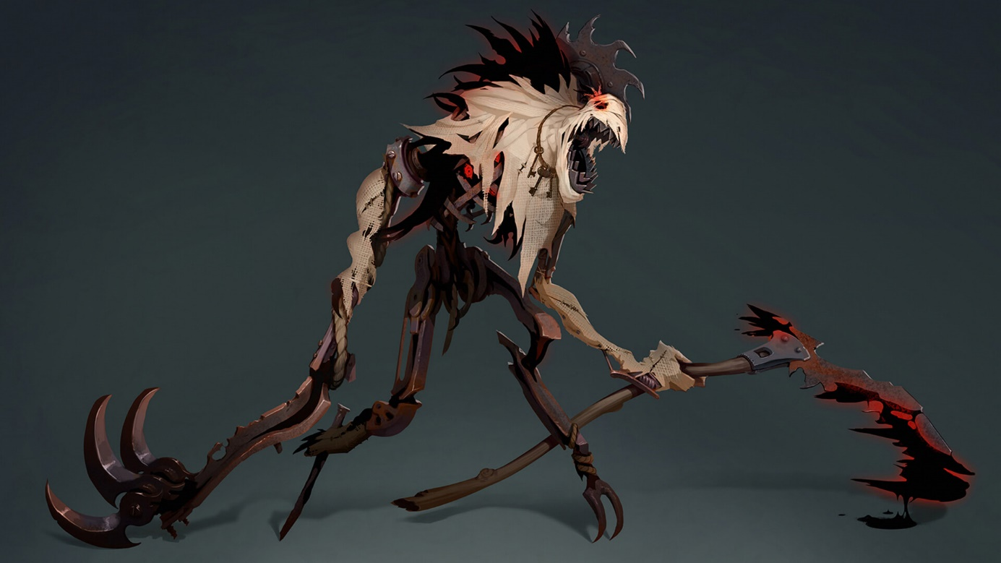

NOTEABLE APPEARANCE FEATURES:

* jagged scythe

scythe's blade is not present, thus it appears as a long stick on which you would assume a farmer tool used to be, when Fiddlesticks uses it to attack it gains a blade of black and red mist (same as the form as his demonic body, described later)

* lantern (optional)

in his other hand he holds an iron lantern, the lantern doesnt seem to do anything, it is not lit

(DM note, if opting for not giving Fiddlestick truesight built in, you could make it so that the lantern gives him truesight of 15 ft., somehow destroying the lantern or taking it away from Fiddlesticks in this case would make him loose the 15ft. truesight)

* iron cage containing the demon inside the scarecrow's chest

the demon is willingly inside the cage, the cage is not magical and does not restrain the demon, still the demon does not abandon the cage in its entirety almost never. the manifestation of the demon can interact with its current plane of existence and it looks like a dark black and red mist that can take simple forms (commonly, a third hand that erupts from the scarecrow's body to cast spells)

(DM note, maybe an interesting feature would be that the scarecrow body is not immune to non magical attacks, but killing the scarecrow doesn't kill the demon. Instead it appears to kill Fiddlesticks but after some time (few days?) Fiddlesticks comes back to life. This could upscale the encounter difficulty but also downscale it as needed. EG. Giving the scarecrow low max HP and not using all of his abilities could make this a lvl 1 encounter, but then Fiddlesticks could reappear later down the line. In this case scarecrow would need to have a separate HP pool from the demon. Demon can only be attacked if the damage targets the demon inside the cage or demon's arms when they extend from the body.)

AGE: infinite/unstated, same as lifespan

GENDER: technically none/realistically male by voice

SPECIES: scarecrow (old DEMON)

EYES: no functional eyes

HAIR: none

SKIN: cloth potato bag, torn

HEIGHT: average human, 180cm?

WEIGHT: straw, wood, and some metal in correspondance to its' height

STATS: (from Scarecrow stat block for 5e, I would recommend rolling for stats or asigning them yourself as oppose to taking scarecrow stats)

AC: 11

HP: 8d8 (as per scarecrow stat block)

STR  
DEX +1  
CON  
WIS +2  
INT +1  
CHA

Resists: bludgeoning, piercing and slashing from nonmagical attacks (if what is stated above is considered, scarecrow's HP is not immune to this, the demon body (the mist inside the cage) is); necrotic damage

Immunities: Poison (damage), charmed, exhaustion, frightened, paralyzed, poisoned (condition), unconscious (unless scarecrow's HP is dropped to 0)

**Any spells that have S component require the demon inside Fiddlesticks to reach out with his arm to satisfy the S component of the spell. During this time, players could attack the arm as it reaches out (by holding an action to use as reaction) to cast the spell and if the attack lands, completely interrupt the spell.**

ACTIONS:

**Claw attack** - Melee Weapon Attack: +3 to hit, reach 5 ft., one target. Hit: 6 (2d4 + 1) slashing damage. Fiddlesticks attacks with his claw on his right hand. If he is usually holding a lantern, a demonic misty arm grabs the lantern while he slashes at his enemies. **CAN FEAR OPPONENTS UNDER CONDITION EXPLAINED LATER.**

Stat block suggests **multiattack** too. I would **only allow for this attack and his cantrip attack** to be able to strike twice at most

**Scythe slash** – Melee Weapon Attack: +3 to hit, reach 15 ft., one target. Hit: 6 (2d4 + 1) necrotic damage. Fiddlestick slashes with his scythe. As he winds up a hit, his left arm extends helped by the misty demon inside it. When the handle in his hand is at the peak of the swing just before the release, scythe's black and red blade conjures as Fiddlestick unleashes his slash. **On hit, it can silence** opponents until the end of their next turn **or** if the opponent was holding a concentration for a magical spell it **can impose a disadvantage on the concentration save** (without silencing the opponent afterwards). **CAN FEAR OPPONENTS UNDER CONDITION EXPLAINED LATER** instead of silencing altogether.

**Necrotic bolt** – ranged spell attack, imagine fire bolt but black and red mote instead of fire. Deals the same ammounts of necrotic damage. (Choosing to phrase it like this because the intended narration of the attack fits the fire bolt more than the chilling touch.) **CAN FEAR OPPONENTS UNDER CONDITION EXPLAINED LATER.** For reference – fire bolt:

Slika na kojoj se prikazuje tekst

Opis je automatski generiran

**Fiddlesticks' probe thoughts** – divination cantrip,   
casting time: bonus action,   
range: unlimited,   
target: a creature Fiddlesticks can see 'with his own eyes' not through reflections or spells (unless a spell opens a portal that could theoretically be physically passed through)  
component: - (not even V or S)  
duration: instantaneous

Fiddlesticks looks deep into the mind of his target, looking for what he likes most: fears, dread and remorse. Fiddlesticks cannot speak with other creatures or commune with them in any other way because he doesn't know how. One thing he can do is mimic. Thus he mimics his opponents greatest fears. Sometimes he remembers the way he mimic'd other peoples' fears and uses them to further scare or lure his victims.

Fiddlesticks uses this cantrip to learn of his targets biggest fears without the target knowing their mind was intruded. Upon Fiddlestick's use of this spell, target can make a WIS saving throw against DC*. Upon a failed save target is none the wiser, upon a successfull one, target realizes something evil is around, but doesn't know what or where just from this success, also if Fiddlesticks' aura was completely suppressed (in tier 2) it now is detectable (goes to tier 1 for a short time stated in the description of See?! it's just a scarecrow). Regardless, Fiddlesticks learns of the target's biggest fear. Against PCs, the DM could ask about their character or connect it to some already known information about the PC's past.

Spell based on this 3.5 spell: (<https://www.d20srd.org/srd/psionic/spells/probeThoughts.htm>) and Detect thoughts.

For any attacks that can fear enemies (marked with: **CAN FEAR OPPONENTS UNDER CONDITION**) Fiddlesticks must have learned of their fear using this cantrip. Only then and when the target was unaware the attack will be able to fear the victim(s). Target can be unaware either during the supprise rounds, first attack from dormant state (his passive) or if the target was either blinded/unable to see or unable to hear and wasn't looking in the direction of Fiddlesticks when he was making the attack(s).

\***DC med-high**, maybe depending on the victims personality (resolve, courage?) – higher DC for weaker minded characters.

**Crow storm** - WIP

**Murder of crows** - WIP

**See?! It's just a scarecrow (passive) - Tier 1** – **after 1 turn** without using any actions or movement, Fiddlesticks assumes the pose of a regular scarecrow. When in this pose he can cast his Probe thoughts without being detected. His next attack counts as being invisible prior to attacking. His demonic body still resonates with a magical aura.

**See?! It's just a scarecrow (passive) – Tier 2 -** **After 2 more turns** (3 total) of being in a dormant scarecrow state, even his aura dims. Undetectable through magic revealing spells. Only specific spells or abilities that are able to detect demons can sense it's presence, but cannot pinpoint its' origin exactly to the scarecrow. If Fiddlesticks' target of his probe memory passes the saving throw, he returns to the previous stage of this passive ability.